**UNSUPERVISED LEARNING - FUZZY C MEANS**

K. Sheetal Reddy

14XJ1A0526

The parameters used were :

m = 2

A = identity matrix

Epsilon = 0.001

The J values and the Iterations for the cluster numbers 2 -10 are as follows:

The Rc ration minimizes for the cluster size : 4

The graph for the Mining Data of size 720 is :

This uses the program Unsupervised.py and the mentioned parameters.

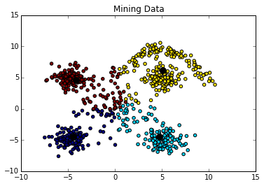

The graph for the Classification data of size 180 is :

The program Classify.py was used in generating this graph.

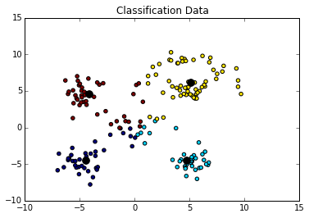

The Unsupervised.py file is a python program that is used for training of the model. It generates a new excel workbook, that contains the Mining Data , Classification Data and the Cluster Centroids. These are used by Classify.py

The software engineering process used was the iterative process.